HUD Research
Bloodstained: Ritual of the Night 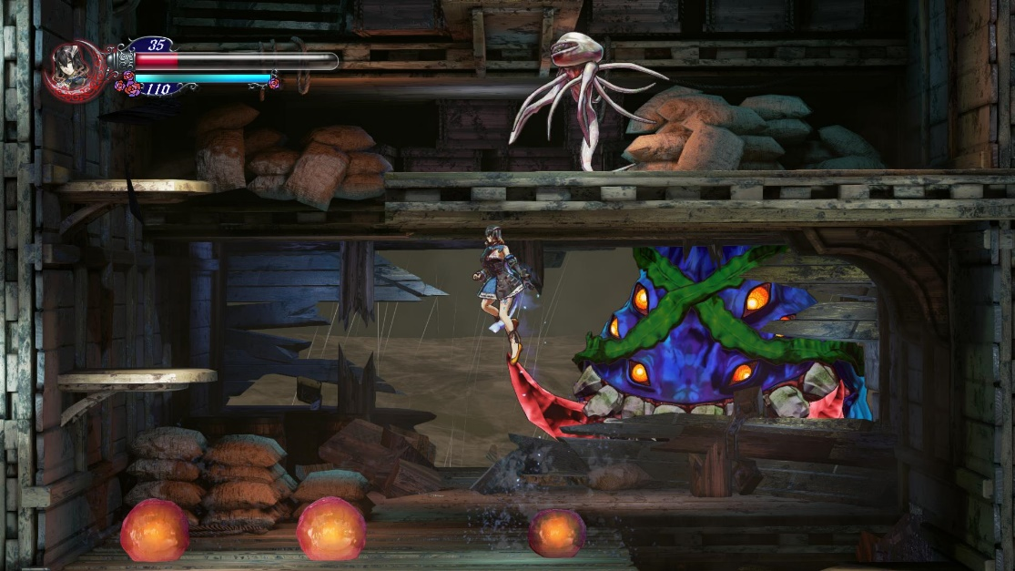
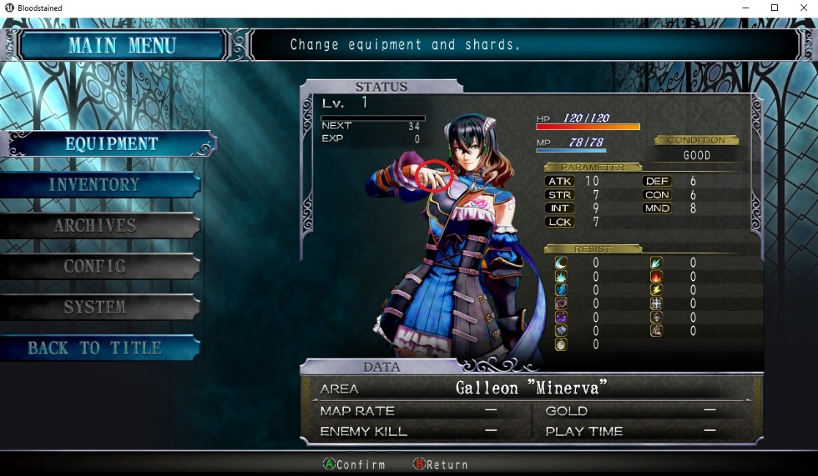
Bloodstained: Ritual of the Night is an indie project Kickstarted and leaded by Koji Igarashi. Bloodstained uses a health gauge which is commonly found in video games such as Kingdom Hearts, Legend of Zelda: Breath of the Wild and Xenoblade Chronicles 2 and while it is needed in some genres, I believe for games such platformers it is an outdated design decision.
It would be a less waste of the players time if we remove the game over screen completely and replaced it with the players losing Ryo (ancient Japanese currency) and return them to the last checkpoint. If the player completely loses their Ryo, then they must redo the entire level again.
Two games that incorporated this new design feature to their franchises are Mario Odyssey and Sonic Forces. Using both Rings (Sonic) and Coins (Mario) not only as your score but your lives as well.
What Happens if you die and have 0 Coins? Super Mario Odyssey
https://www.youtube.com/watch?v=UxWHerzpRA4
100 Ways to Die In SONIC FORCES "Modern Sonic"
https://www.youtube.com/watch?v=bb7HyrlSdI8
Also, to avoid making an undesired player experience, it may be best not to clutter the UI menu with too much stuff and try to simplify things, making it more stress free. An example of this would be no scrolling menu’s, making it a pain to find that “one item” needed for a chest or door maybe.
Super Mario: 3D World
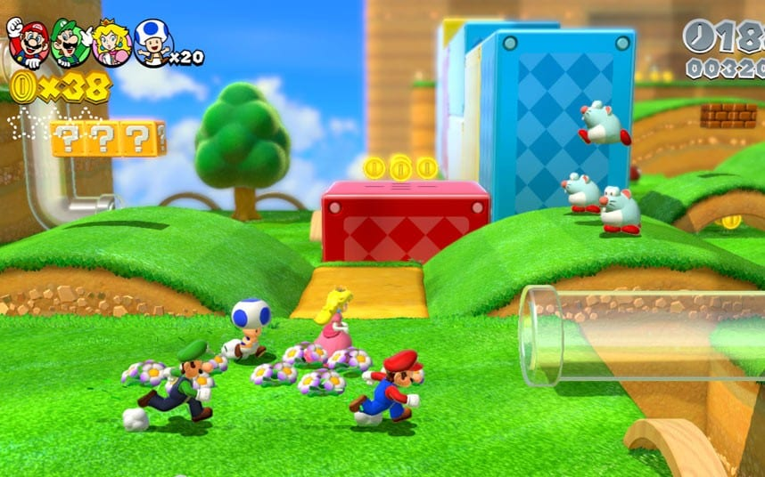
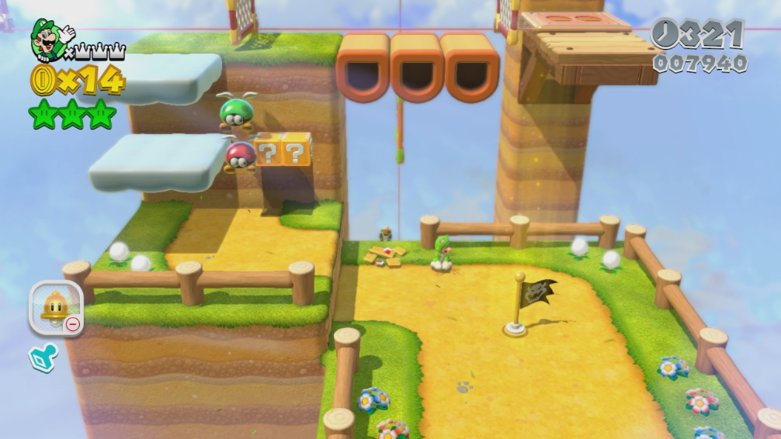
Notice how each HUD fits right in perfectly with the type of theme the game is going for? When designing the HUD of the game, I believe it’s something important to consider otherwise everything will look out of place.
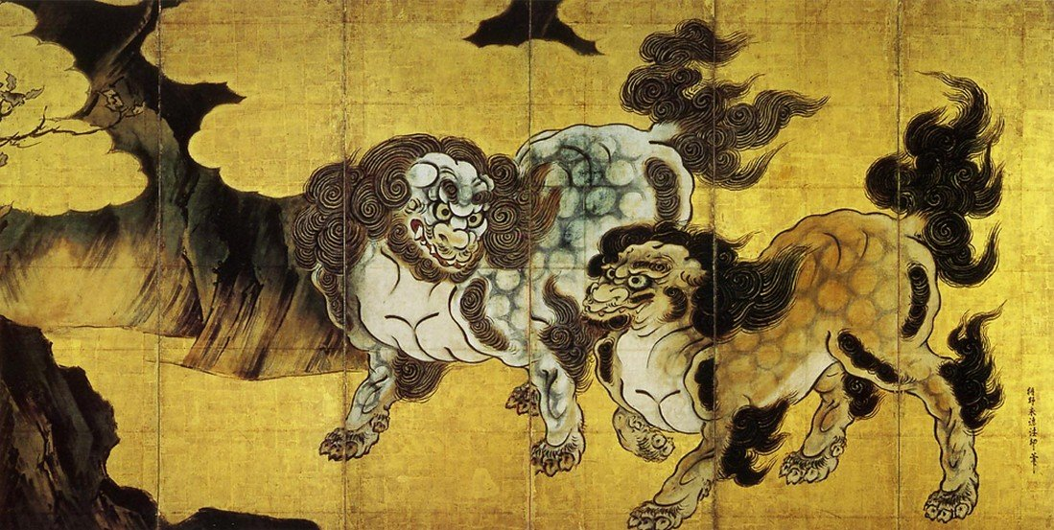
Since our game is very Japanese themed, I thought researching into Japanese art like the legendary artist Katsushika Hokusai would be a great start to design our HUD around.

References:
Pure Miriam (2017). TRIVIA: Things you may haven't noticed before at the DEMO. [online] Bloodstainedfanforums. Available at: http://i.imgur.com/PsdmeuJ.jpg [Accessed 23 Jan. 2018].
Cunningham, J. (2016). Bloodstained: Ritual of the Night Upholds the Castlevania Legacy. [online] Hardcoregamer. Available at: https://www.hardcoregamer.com/wp-content/uploads/2016/06/Bloodstained01.jpg [Accessed 23 Jan. 2018].
moderntokyonews (2015). Japanese Art and Cultural Impact of Oda Nobunaga: Kano Eitoku. [online] Modern Tokyo News. Available at: https://moderntokyonews.files.wordpress.com/2014/07/kano_eitoku.jpg [Accessed 23 Jan. 2018].
Hoggins, T. (2013). E3 2013: Super Mario 3D World hands-on preview. [online] Telegraph. Available at: http://i.telegraph.co.uk/multimedia/archive/02588/WiiU_SuperMario_sc_2588510k.jpg [Accessed 23 Jan. 2018].

